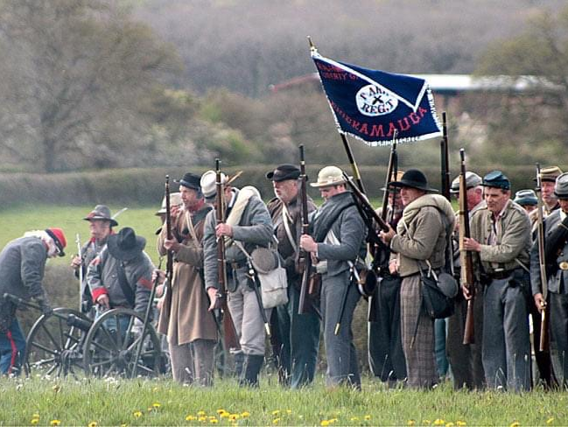
Southern Skirmish Association

Bugle Call
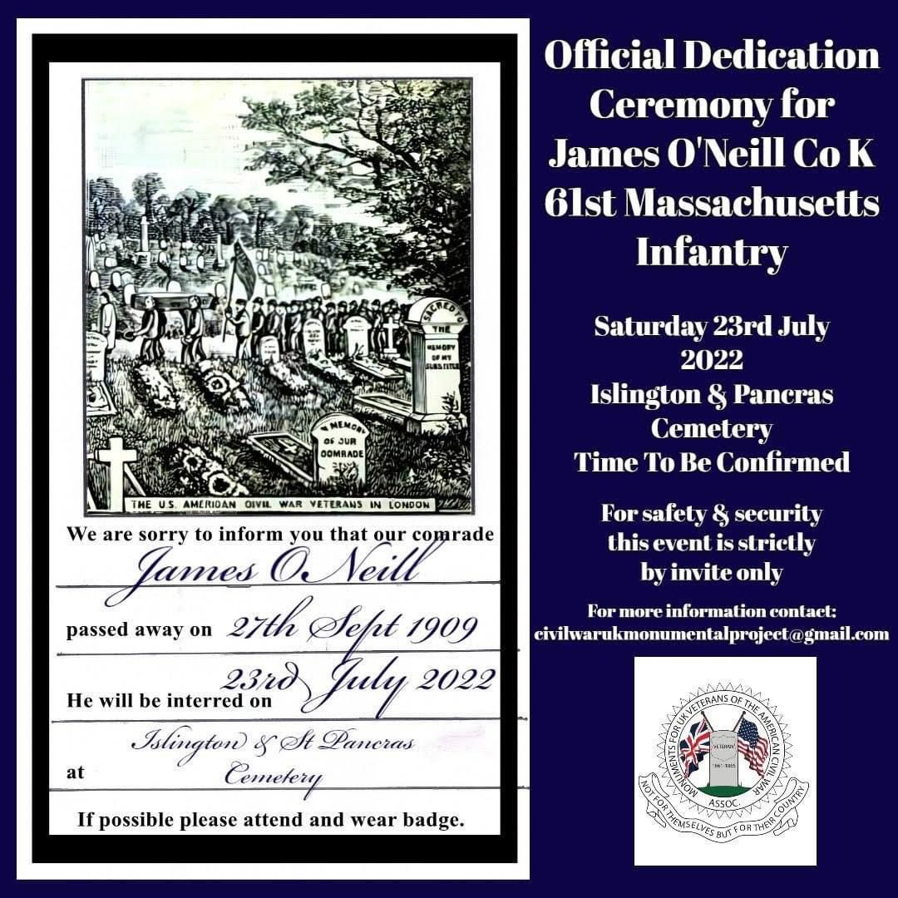
Hello Readers, hope you enjoy the new season and new format. Any comments do let me know. Please enter the competition later in the magazine and thanks to the contributors and Mr Craig Semplis from whom I've pinched photos. Made with my Ipad Pro and pages and sweat and tears. See you on the battlefield! If there is content you’d have like to seen eg the Laredo anniversary or the Falklands War anniversary..get off your butt and write something..

John Oakley, Secretary and Editor

May 2022

Editorial
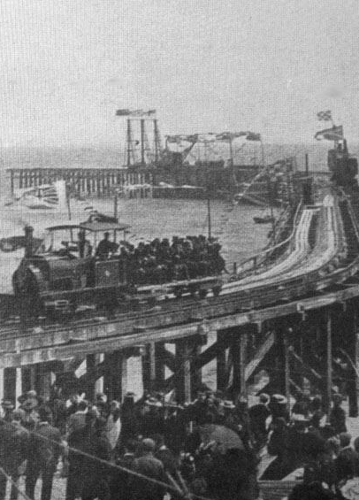
Hastings Harbour Arm opening 1875

Hastings Jubilee!
A plea from Stuart - Our esteemed Chairman
The Hastings event really grew out of little more than a one day event for the artillery. We had decided that back-to-back events weren’t popular but then due to lack of numbers we lost Pippingford Park and therefore the whole of May with nothing doing.
Suddenly I was asked by the chair of the Bonfire Society if we could do a 70 gun salute. I did actually reply asking, “had they been drinking.” The return message I won’t repeat. needless to say the Council wanted a spectacular event. It has become a full blown paying, all singing and dancing charity event, all you have to do is turn up.

This Platinum Jubilee will never happen again. It should be, and hopefully it will be,
a real spectacle for Soskan, that will capture not only the participating local public but the media as well .
The Royal Artillery can’t put on a display as well as you lot. The Queen only got a 21 Gun Salute for her birthday. With the support of the infantry it can be done.
We will have at least two displays on show, Mick & Joe’s award winning displays, plus the memorial stall .
In the evening you can partake of the town’s entrainment or take part in the round Britain beacon lighting at 21.30 hrs on the East Hill or just relax with a beer at the farm.
What more can you ask ?
Boat trips on Friday 😂😂😎
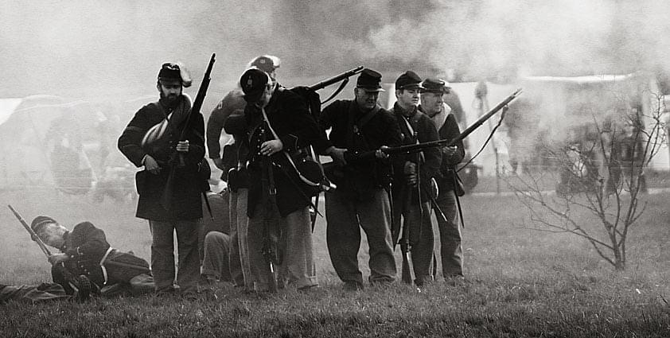

Hastings details
Please find details of the campsite for the Hastings event

Campsite details
Lidham Farm
Winchelsea Rd
TN35 4LW

The site will be available from midday Wednesday, the 1st of June until Saturday, the 4th of June .
there is one water point and at least three if not four portaloos , the site has excellent access and the entrance will be marked with a flag.

The campsite is completely private so no need for living history camping

Muster at the farm at 8:30 am on the 2nd of June and then move all personnel and guns down to Hastings seafront , not everyone will need to take a vehicle as we can shuttle backwards and forwards the 2 miles .

once assembled on the beach we can deploy the guns on the harbour arm and put up the displays on the Stade a large area adjacent to the harbour arm .
Just in case youve lost them
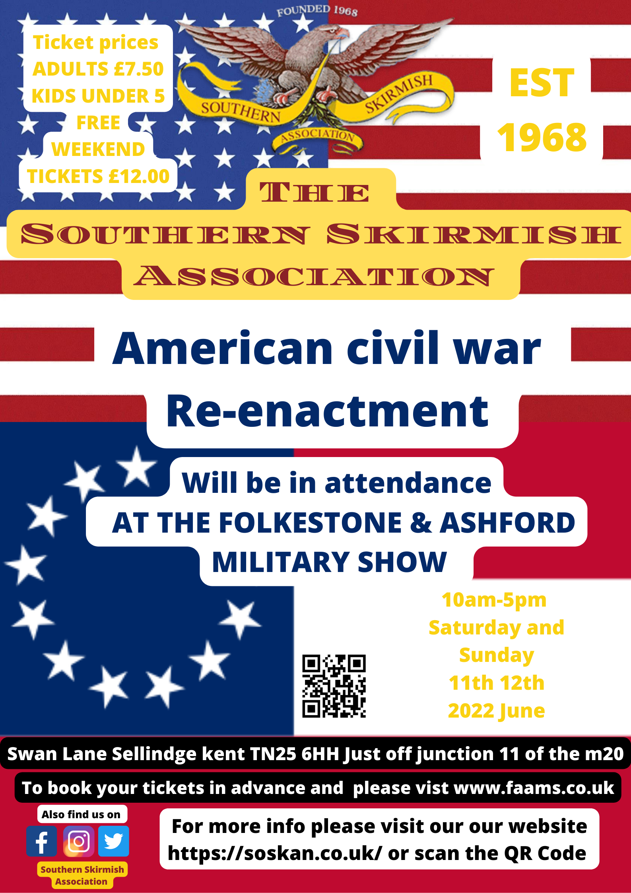
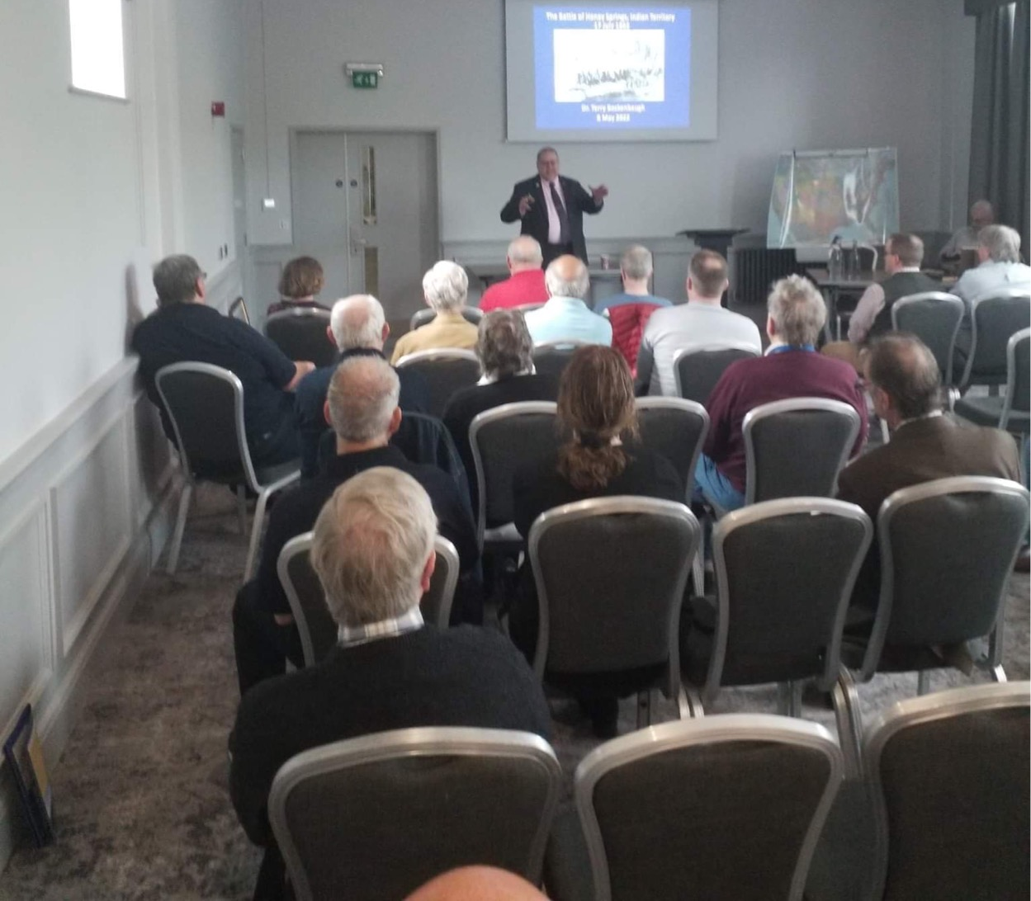

Civil War Round Table
Over the weekend of the 7th 6th and 8th of May myself and many other members of the American Civil War Round-Table UK attended the Annual Spring Conference.
This year Theme was War in the Trans-Mississippi which is not everyone's favourite part of the civil war
I myself was abit apprehensive before I attended but come away with a bigger appreciation for that part of the civil war one of the reasons being that the Speakers we're all amazing
Each year's conference with an icebreaker in which Mike Somerville and ACWRTUK Ryan Diamond Argued there case of why and why not the Trans-Mississippi was Important
Three of the speakers were from the US, one from the UK and the other from Italy who is American but living in Italy and who is also a member of the Round-Table UK.
Not only that I got to spend the weekend with some great like minded people (Civil War buffs )
So who were the speakers and what was there topics we had the pleasure and privilege of receiving Lectures from Dr Terry Beckenbaugh and yes football/soccer fan he is a distant relative to Franz Beckenbaugh the German Footballer
Terry covered two topics the first being Missouri 1861 and the Battle of Honey Springs
Dr Kyle Sinisi who covered General Samuel R Curtis and The Battle of Westport
And Dr Jeff Prushankin
Who covered General Kirby Smith and The Red River Campaign.
Kevin Waite covered
The Lost cause goes west The confederacy in post war California.
Kevin has recently authored a book Called West of Slavery well worth a read

American civil war Round Tables very own member Erick Bush covered Texas The Civil War's Western Bastion.

Saturday Evening we All Enjoyed a Formal Dinner and Sunday morning we had an auction in which a former member of The ACWRTUK had unfortunately passed away and he donated all of his Civil War related Books picture and much more.
If anyone is interested in joining the American Civil War Round-Table UK than please visit our website as well as a Annual conference we meet in London every second month and have a zoom presentation one's a month and most of all get to talk about our Passion with other like minded people.

You will be available to see all of the talks including the icebreaker on American civil War Round-Table UK YouTube channel in the Autumn.
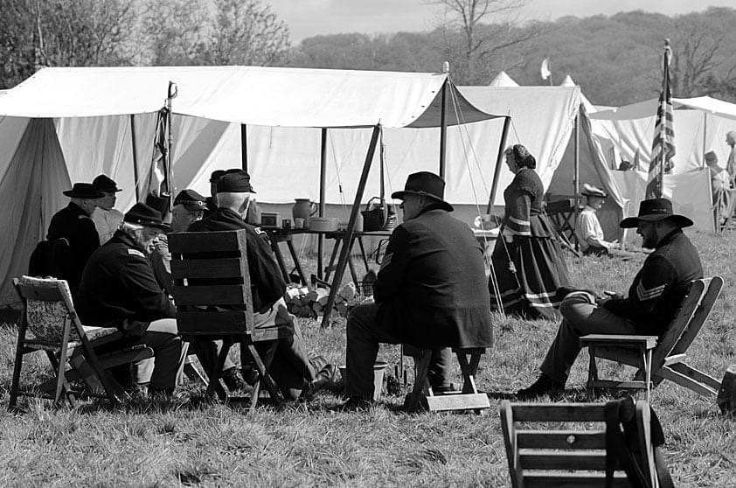
Relaxation mode on at Frome
Darren sits in a sweaty hotel conference room at weekends (cont)
Dr Kyle Sinisi who covered General Samuel R Curtis and The Battle of Westport And Dr Jeff Prushankin who covered General Kirby Smith and The Red River Campaign.
Kevin Waite covered The Lost cause goes west and The confederacy in post war California.
Kevin has recently authored a book Called West of Slavery well worth a read American civil war Round Tables very own member Erick Bush covered Texas The Civil War's Western Bastion.
Saturday Evening we All Enjoyed a Formal Dinner and Sunday morning we had an auction in which a former member of The ACWRTUK had unfortunately passed away and he donated all of his Civil War related books pictures and much more.
If anyone is interested in joining the American Civil War Round-Table UK than please visit our website as well as a Annual conference we meet in London every second month and have a zoom presentation one's a month and most of all get to talk about our Passion with other like minded people.
You will be available to see all of the talks including the icebreaker on American civil War Round-Table UK YouTube channel in the Autumn.
(Glad you had a great time Darren, hope there was a free bar! Phew! Mr Editor)
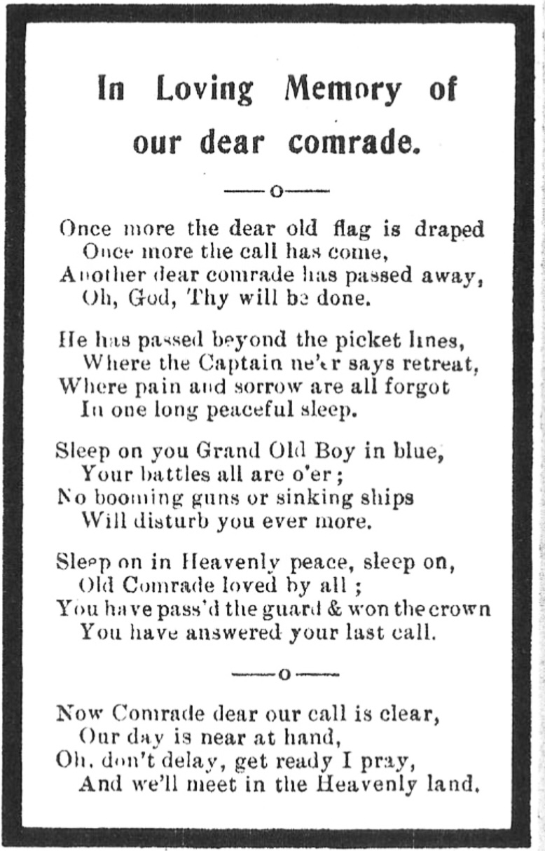
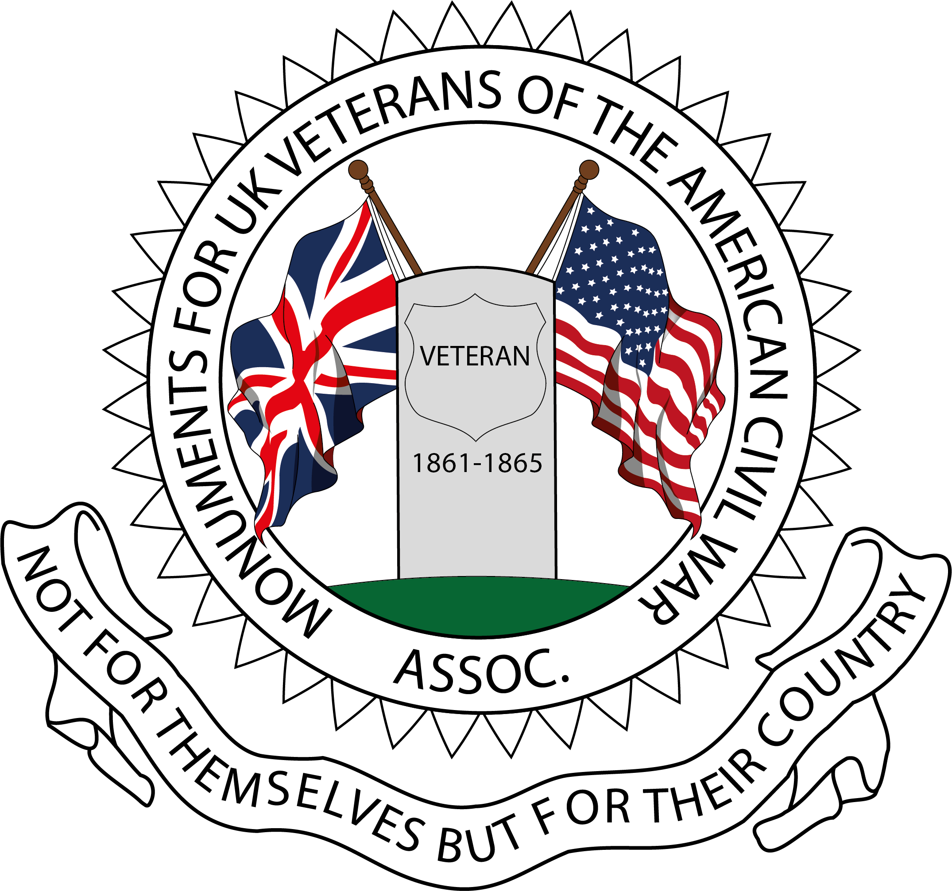

UK Civil War monument project
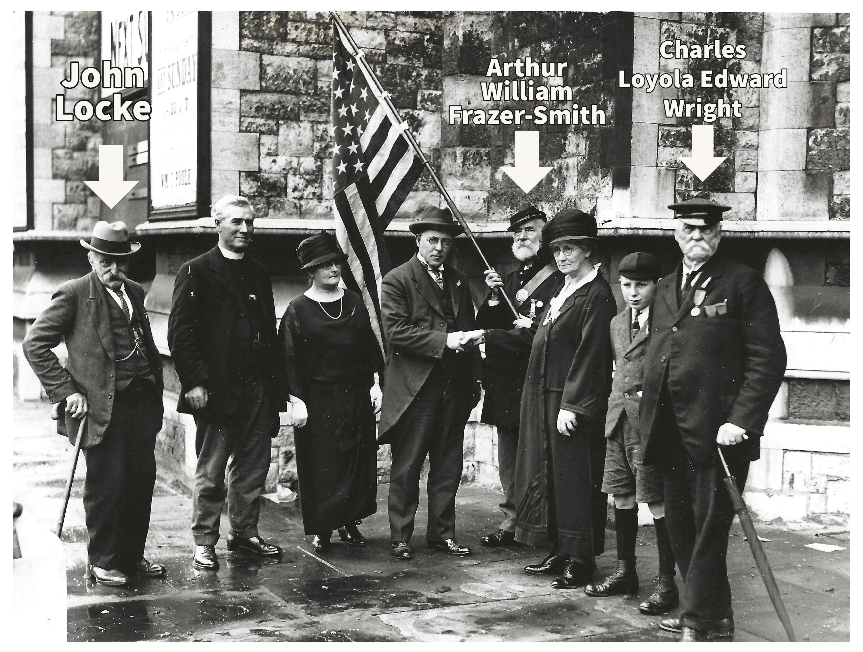

“The Bluecoats of Bermondsey.

As a young child, I heard stories about a family member who had served in the American Civil War and received a pension from the United States government until the day he died. His identity was shrouded in mystery until about the year 2005, when , by tracing my Denham roots, I realised the veteran was my Great-Great Grandfather George Denham.
George was born in Grantham on April 23rd, 1835. His fathers’ employment as a plasterer during a time of industrial revolution resulted in young George having to move with his siblings to several towns and cities in the Midlands, before settling in Clapham in South London in the 1840’s. His father Thomas died when George was just eight years old. And in his early teenage years he found himself encountering diverse cultures drawn to the nations’ capital. Such encounters may have fuelled his desire to see the world beyond London. In around 1856 on an account of some form of argument with his family he ran away to the United States where he enlisted in the US Navy at Brooklyn, New York City. He served onboard the USS St Lawrence as part of the Brazil squadron until 1859.
After naval service he lived for a time in Boarding Houses in Philadelphia, and in August 1863 enlisted as a substitute in Company F, 111th Pennsylvania Volunteers. He served during significant battles at Wauhatchie, Lookout Mountain, Missionary Ridge, and Ringgold. For several months he spent time with the 109th Pennsylvanians at Bridgeport, Alabama, on picket duty whilst Union forces reconstructed a bridge across the Tennessee River.monsters”, at Mobile Bay and the culmination of all his experiences left a legacy of mental and physically injury that would remain throughout his life. In 1865 he was discharged from Naval service due to ill-health caused by his military service and he returned to his family living in Somers Town, North London, England. In 1895 , his services virtually forgotten by a once grateful nation, he began the challenging process of seeking to secure a federal pension from, “Grand Conquistadors” at the Pension Bureau in Washington DC.

John was a preacher for the London City Mission. Like George, he had left home at a young age to go to America. At the age of 14, he left Hampshire behind and went to sea. After sailing around the world for several years, he made his way to America where he spent his time drinking, gambling, and womanising. By all accounts, it was a hard-leaving life. On more than one occasion he was robbed of all his possessions in houses in brothels. Onboard one ship he had witnessed a sailor start the day with $1000 and gambled it away until he was just left with just the shirt on his back by the evening. John experienced similar loss through gambling - eventually, he found himself penniless and destitute in New York. A solution to his situation presented itself, serving the Union. He enlisted in the US Navy in 1862 aboard the ship USS North Carolina. The same ship that George had rendezvoused at several years earlier.

During his service, John survived six days of a fierce battle on the Mississippi and was cast in irons for being drunk during an anti-smuggling operation on the Potomac River. John later went aboard the USS Tulip, a 101-foot steam gunboat and was appointed as acting master’s Mate on 9th June 1864.

On November 11th, 1864, whilst George was encamped below Lookout Mountain down in Tennessee with the army of the Potomac, John was on the USS Tulip in the River Potomac. The vessel was heading for the Navy yard at Washington DC. Whilst on route one of the vessel's boilers exploded, in a blinding rush of steam and glare of fire that could be seen for miles around. John found himself in the moonlit water with seventeen others of the crew. However, only he and two other crew members ultimately survived. 62 other crew members lost their lives. John was able to drag himself from the freezing water. He continued his services with the Navy and by 13th December 1864 was the youngest serving ensign of the US Navy. He resigned on 17th May 1865.

After being discharged from Naval service, he carried the trauma of his experiences, as George probably did. The guilt of being one of the few survivors of the Tulips explosion nagged at him for the next ten years. He briefly spent time in the Australian goldfields and then returned to England and gained employment as a gateman in the docks of London. Trauma and living life to its excess had taken their toll. He felt he had lived a sinful life and was only able to come to terms with what had happened in his younger days, by repenting at a London City Mission meeting, where his Christian faith was born. He gave up drinking, and later devoted the rest of his life to the work of the Mission. In that role, he sought to relieve hardship experienced by the slum inhabitants of the East End, who lived in a state of abject poverty and sought to improve their lot, to save their souls.

When George and other veterans first encountered John Davis, they would have met someone described as, “Between sixty and seventy, thick-set, broad-shouldered, slightly under medium height, with a full moustache and bushy beard, rapidly turning grey. A full short neck bears up a well-shaped, massive head. The forehead is high and ample. The eyes deep-set, small, and keen, can twinkle with mirth, fill with tender pity, or flash with righteous anger. The outer man is garbed in a reefer jacket on which the badge of the Lifeboat Rescue Crews shows. In conversation, the voice is soft and pleasant, and the bearing, while manly, is marked by a gentle courtesy and humility”, according to the Author Michael Hammerson.
John in 21st century parlance would probably be best described as a,” Mover and shaker”. He utilised the power of early 20th century newspapers to raise awareness of Civil War veterans in London, who were often found living in, “Straightened circumstances”. According to an article in the Buffalo Morning Express, Davis said he had many encounters with veterans at the United States Consulate in London, which turned to his mind to create opportunities for fellowship and support, “Many a time I have met some of my comrades at the Consulate, we have said, “Why can’t we get closer in touch with one another?” We are getting old, and frequently our dead do not have the honor [sic] of the American flag laid over their graves. So I thought we would try to form some sort of a society of our own whereby we might have the opportunity of meeting each other at intervals.”
John Davis offered men like my Great-Great Grandfather hope, friendship, and fellowship. Furthermore, he had lived experience of the Civil War, he was relatable as a former sailor who had served on the same receiving ship USS Carolina, as had many other London based Naval veterans. John Davis was a man of faith; he was genuine and supportive. John McElroy of Washington Daily Journal, a Veteran of the 16th Illinois Cavalry, described him as, “One of the noblest of men, with a great brain and executive ability and a heart even bigger than that. You can have the constellation of feeling that no man has lived his life to a better purpose”

In 1910 John Davis put his life to even greater purpose and initiated the formal organisation of sixty civil war veterans. Their numbers would eventually grow to over 100 members. The London Branch of American Civil War veterans was inaugurated on September the 20th 1910, in Bermondsey, South London and George Denham became its eighth member among the “Bluecoats”.

The Branches eleventh member was James Henry Cleggett who arrived in London from the United States in about 1908. James was born June 24th, 1845, in Rochester, New York, the son of James Cleggett. According to the Sioux City Journal James was apparently, “Greatly respected by his brother veterans… for his knowledge of consular red tape - he had the details of the United States pension office at his fingertips.” Such knowledge was incredibly valuable to John Davis because the connections to comrades had with each other were informal and not officially organised. The veterans only had their membership to the Grand Army of the Republic (GAR) which had been formed many years earlier in the United States. However the GAR was too far away to offer immediate, and tangible support, but with men like James Cleggett, John Davis, and George too, the eclectic group of former soldiers and sailors based in London and the home counties were able to create a better sense of fellowship with each other. Connection had helped to sow the seeds of forming a London Based Association.

According to the London Daily News Davis had been “Most assiduous also in tracing the veterans, many of whom were in ignorance of the legislative provision made for them by the American Government. Through his efforts some who were in abject poverty” had been able to receive of pensions of “£5 or £6 [sic] a month”. The Graphic recalled that Davis, was a “picturesque character,” and “The ideas of the Posts of the Grand Army of the Republic, to be found in every town and village in the United States, appealed to him so that he desired to see a parallel organisation for the veterans living in England. Some of them, not knowing the benefits which the Grand Army of the Republic (an organisation of the same nature as the Comrades of the Great War) had won for them, had fallen on evil days. Whether in workhouse, almshouse, or prosperity, John Davis got in touch with them”

Because of the formation of the London Branch George found himself in a fortunate position of being once again among the ranks of other civil war veterans, revisiting his youth and enjoying, “Fraternising, Fellowship, Camp Fire Tales, Lower Deck yarns, Jabbering and Singing those long-ago Battle Hymns”. The fraternising had fringe benefits too, the connected veterans were able to support each to obtain pensions or have them increased.

On the 24th of September 1912, two London Branch members acted as witnesses for George when he visited the United States Consulate for a Pension increase; Robert Davis and William Soper. Soper was the branch's fifteenth member, he lived in Barking and was employed as a lighterman. He had common ground with George, having been a former Able Seaman on the vessels USS North Carolina and Wabash between 1861 and 1864. William had also got discharged in Philadelphia where George had lived as a young man in boarding houses. Robert the branches twenty-sixth member had been a navy man too, he had served on the vessels USS Vermont, Carolina and Commodore McDonagh having enlisted in 1861 and served until 1868 when he was discharged. Robert was 12 years younger than George, a painter by trade – he lived in Albany Road, South -East London. Thanks to their support George had his pension raised to the maximum amount of $30 Dollars.

The fellowship and benefits of the London Branch was to be short-lived, and George passed away at 134 Malden Road , Kentish Town, on January 19th, 1914. The branch itself lived on, continuing to raise its profile, even when John Davis passed away in 1917. With the demise of the “picturesque character”, Davis, Arthur William Frazer Smith, the branches fifty-ninth member took over the reins of honorary secretary.

Arthur was born in in Coventry, Warwickshire and had served with Company H 80th New York Volunteers. In post war life he had settled in London and like his peer John Davis had become a missionary too. According to an article he wrote in the Seminole Producer of Seminole, Oklahoma on 14th February 1928, there were just eleven men left in the branch after its formation eighteen years earlier. One of those men was Charles Loyola Edward Wright. His civil war service was onboard the USS Vandalia. Charles was probably born in Cambridgeshire in 1847 but baptised in Hackney, East London. When Arthur died 27th January 1932, Charles was thought to be the last remaining survivor of the “Bluecoats” that had congregated at Bermondsey for so many years. Charles died a year later, on 23rd August 1933 at Camberwell. He was buried in the Wright Family plot at St Peters Churchyard Ightham, near Sevenoaks, Kent.

It has been suggested that with the passing of Charles Wright, "Taps" had sounded for the London Veterans for the last time. However, the last member of the London Branch died in 1940, his name was Samuel Lander Hough. Samuel was named as one of the eleven remaining survivors in the Seminole Producer article of 1928.

Samuel was born on 7th April 1848 in Derby, Derbyshire. He served during the years 1864 to 1865 in Co G 2nd New Jersey Cavalry. Enlisting at the age of 15, as Samuel Huff, as a private on 8 Sep 1864. He died on 26th December 1940. As the last identified London Branch member, his passing marked the demise of a unique organisation outside of the United States of America that had sought to improve the lot of veterans of the American Civil War.

I had not learnt about the London Branch of American Civil War veterans until September 2020 when organising a dedication ceremony for the official headstone we obtained for George Denham. And it seems that with only a few people raising awareness of this organisation its work to honour the service of veterans outside of the United States has largely been forgotten. Those veterans seemed to gain something from their fellowship, and it seemed a travesty to me that such work had almost been lost from the pages of American Civil War history. Sometimes events happen that can turn the tide of change, and this is exactly what happened as an outcome of the fellowship and connection that arose from the dedication ceremony held for George Denham, I met other like-minded people who wanted to build on the strong foundations created by the London Branch of American Civil War Veterans. They fought for their pensions; we would fight for their remembrance.

In January 2022 “Monuments for UK Veterans of the American Civil War Association” was formed. It is the London Branches spirit of sharing knowledge, inclusion and peer support that underpins the foundation of the Association, which is part of its constitution. The Association seeks to foster an environment of fellowship and sense of belonging; with each other, and to those long departed Civil War veterans.

Its first official public event was in April 2022 at Lincoln Cemetery, Cook County Illinois, where along with members of the Sons of Union Veterans of the American Civil War, (SUVCW) and Women’s Relief Corps, (WRC) we undertook a dedication ceremony for James Cleggett. James had returned to the United States in 1929, where he had died near Chicago. Through the Associations work we were able to alert the SUVCW and WRC about James unmarked burial location, civil war service and life, and feel a sense of pride at the outcome of contacting them. He was honoured and a headstone will now be secured. Any by collaborating with the SUVCW and WRC we have shared further information about other veterans and the London Branch too.

Of course, there are several strands to the Associations work – to fund one single monument to honour the service men and women who served. But also, we will endeavour, where possible, to secure single headstones for their unmarked graves, and create “virtual” monuments online and at events to shed light on their service so that they will not be forgotten. An important part of our work is building on existing surviving lists of veterans so that they are accessible for anyone to view via our social media pages. Information will include the veterans service, dates and places of birth and death too. We hope that by shedding light on their lives during and post war, others will be encouraged to join our work. Which includes cemetery visits as part of field research.

To fund one single monument is not without cost, however, and we are already in the process of formalising its design and wording. So far, we have raised just over £1000 of a £3000 target. But we still need more support. So people wishing to donate can currently do so via paypal using civilwaruknonumentalproject@gmail.com or our “Just Giving Page” https://www.justgiving.com/crowdfunding/americancivilwarukmonumentalproject?utm_term=DZrnvrD7A

Anyone interested in our work is a stakeholder, the only official membership is by joining as a committee member, which brings with it voting rights that allows members to shape the Associations future. Its early days for the Association but as a daughter of a Union Veteran of the American Civil War, I feel too many years have gone by where all American Civil War Veterans should have been honoured in the United Kingdom. We feel actions speak louder than words; American Civil War veterans deserve proactive remembrance, and we plan to fulfil that duty. We will collaborate with any like-minded organisations or individuals to achieve that aim, so that men like my Great-Great Grandfather George Denham are never forgotten.

Adapted from, “The Spartan who climbed Lookout Mountain” by Gina Denham, 2022.

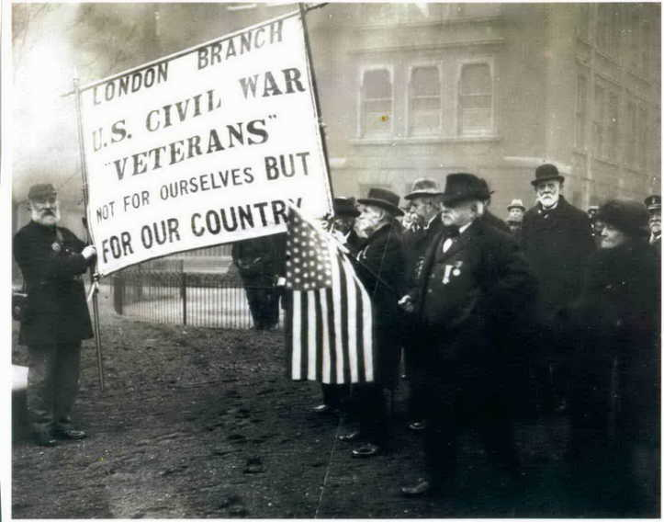

The monuments project (cont)
In 1864, because of a proclamation by President Lincoln, that former soldiers with maritime experience could transfer to the Navy, George made his way to Cairo, Illinois, bidding farewell to his Pennsylvanian comrades. He served as a 2nd class fireman onboard the state-of-the-art ironclad, USS Chickasaw and was a participant in the Battle of Mobile Bay. He saw the conclusion of the war at Spanish Fort. His civil war experiences involved numerous brushes with death where the odds were stacked against him.
As a Private in the Union army, he witnessed the horrors of the war, which included the sight of federal soldiers stacked in heaps like “shingles on a roof”. During naval service he saw , “Writhing giants” and “sea-monsters”, at Mobile Bay and the culmination of all his experiences left a legacy of mental and physically injury that would remain throughout his life. In 1865 he was discharged from Naval service due to ill-health caused by his military service and he returned to his family living in Somers Town, North London, England. In 1895 , his services virtually forgotten by a once grateful nation, he began the challenging process of seeking to secure a federal pension from, “Grand Conquistadors” at the Pension Bureau in Washington DC.
As an outcome of contact with the United States Consulate in London, he met other London-based civil war veterans. One of the key individuals among those veteran was a Missionary called John Davis.
John was a preacher for the London City Mission. Like George, he had left home at a young age to go to America. At the age of 14, he left Hampshire behind and went to sea. After sailing around the world for several years, he made his way to America where he spent his time drinking, gambling, and womanising. By all accounts, it was a hard-leaving life. On more than one occasion he was robbed of all his possessions in houses in brothels. Onboard one ship he had witnessed a sailor start the day with $1000 and gambled it away until he was just left with just the shirt on his back by the evening. John experienced similar loss through gambling - eventually, he found himself penniless and destitute in New York. A solution to his situation presented itself, serving the Union. He enlisted in the US Navy in 1862 aboard the ship USS North Carolina. The same ship that George had rendezvoused at several years earlier.

During his service, John survived six days of a fierce battle on the Mississippi and was cast in irons for being drunk during an anti-smuggling operation on the Potomac River. John later went aboard the USS Tulip, a 101-foot steam gunboat and was appointed as acting master’s Mate on 9th June 1864.
On November 11th, 1864, whilst George was encamped below Lookout Mountain down in Tennessee with the army of the Potomac, John was on the USS Tulip in the River Potomac. The vessel was heading for the Navy yard at Washington DC. Whilst on route one of the vessel's boilers exploded, in a blinding rush of steam and glare of fire that could be seen for miles around. John found himself in the moonlit water with seventeen others of the crew. However, only he and two other crew members ultimately survived. 62 other crew members lost their lives. John was able to drag himself from the freezing water. He continued his services with the Navy and by 13th December 1864 was the youngest serving ensign of the US Navy. He resigned on 17th May 1865.
After being discharged from Naval service, he carried the trauma of his experiences, as George probably did. The guilt of being one of the few survivors of the Tulips explosion nagged at him for the next ten years. He briefly spent time in the Australian goldfields and then returned to England and gained employment as a gateman in the docks of London. Trauma and living life to its excess had taken their toll. He felt he had lived a sinful life and was only able to come to terms with what had happened in his younger days, by repenting at a London City Mission meeting, where his Christian faith was born. He gave up drinking, and later devoted the rest of his life to the work of the Mission. In that role, he sought to relieve hardship experienced by the slum inhabitants of the East End, who lived in a state of abject poverty and sought to improve their lot, to save their souls.
When George and other veterans first encountered John Davis, they would have met someone described as, “Between sixty and seventy, thick-set, broad-shouldered, slightly under medium height, with a full moustache and bushy beard, rapidly turning grey. A full short neck bears up a well-shaped, massive head. The forehead is high and ample. The eyes deep-set, small, and keen, can twinkle with mirth, fill with tender pity, or flash with righteous anger. The outer man is garbed in a reefer jacket on which the badge of the Lifeboat Rescue Crews shows. In conversation, the voice is soft and pleasant, and the bearing, while manly, is marked by a gentle courtesy and humility”, according to the Author Michael Hammerson.
John in 21st century parlance would probably be best described as a,” Mover and shaker”. He utilised the power of early 20th century newspapers to raise awareness of Civil War veterans in London, who were often found living in, “Straightened circumstances”. According to an article in the Buffalo Morning Express, Davis said he had many encounters with veterans at the United States Consulate in London, which turned to his mind to create opportunities for fellowship and support, “Many a time I have met some of my comrades at the Consulate, we have said, “Why can’t we get closer in touch with one another?” We are getting old, and frequently our dead do not have the honor [sic] of the American flag laid over their graves. So I thought we would try to form some sort of a society for members. The London Branch of American Civil War veterans was inaugurated on September the 20th 1910, in Bermondsey, South London and George Denham became its eighth member who arrived in London from the United States in about 1908. James was born June 24th, 1845, in Rochester, New York, the son of James Cleggett. According to the Sioux City Journal James was apparently, “Greatly respected by his brother veterans… for his knowledge of consular red tape - he had the details of the United States pension office at his fingertips.” Such knowledge was incredibly valuable to John Davis because the connections to comrades had with each other were informal and not officially organised. The veterans only had their membership to the Grand Army of the Republic (GAR) which had been formed many years earlier in the United States. However the GAR was too far away to offer immediate, and tangible support, but with men like James Cleggett, John Davis, and George too, the eclectic group of former soldiers and sailors based in London and the home counties were able to create a better sense of fellowship with each other. Connection had helped to sow the seeds of forming a London Based Association.

According to the London Daily News Davis had been “Most assiduous also in tracing the veterans, many of whom were in ignorance of the legislative provision made for them by the American Government. Through his efforts some who were in abject poverty” had been able to receive of pensions of “£5 or £6 [sic] a month”. The Graphic recalled that Davis, was a “picturesque character,” and “The ideas of the Posts of the Grand Army of the Republic, to be found in every town and village in the United States, appealed to him so that he desired to see a parallel organisation for the veterans living in England. Some of them, not knowing the benefits which the Grand Army of the Republic (an organisation of the same nature as the Comrades of the Great War) had won for them, had fallen on evil days. Whether in workhouse, almshouse, or prosperity, John Davis got in touch with them”

Because of the formation of the London Branch George found himself in a fortunate position of being once again among the ranks of other civil war veterans, revisiting his youth and enjoying, “Fraternising, Fellowship, Camp Fire Tales, Lower Deck yarns, Jabbering and Singing those long-ago Battle Hymns”. The fraternising had fringe benefits too, the connected veterans were able to support each to obtain pensions or have them increased.

On the 24th of September 1912, two London Branch members acted as witnesses for George when he visited the United States Consulate for a Pension increase; Robert Davis and William Soper. Soper was the branch's fifteenth member, he lived in Barking and was employed as a lighterman. He had common ground with George, having been a former Able Seaman on the vessels USS North Carolina and Wabash between 1861 and 1864. William had also got discharged in Philadelphia where George had lived as a young man in boarding houses. Robert the branches twenty-sixth member had been a navy man too, he had served on the vessels USS Vermont, Carolina and Commodore McDonagh having enlisted in 1861 and served until 1868 when he was discharged. Robert was 12 years younger than George, a painter by trade – he lived in Albany Road, South -East London. Thanks to their support George had his pension raised to the maximum amount of $30 Dollars.

The fellowship and benefits of the London Branch was to be short-lived, and George passed away at 134 Malden Road , Kentish Town, on January 19th, 1914. The branch itself lived on, continuing to raise its profile, even when John Davis passed away in 1917. With the demise of the “picturesque character”, Davis, Arthur William Frazer Smith, the branches fifty-ninth member took over the reins of honorary secretary.

Arthur was born in in Coventry, Warwickshire and had served with Company H 80th New York Volunteers. In post war life he had settled in London and like his peer John Davis had become a missionary too. According to an article he wrote in the Seminole Producer of Seminole, Oklahoma on 14th February 1928, there were just eleven men left in the branch after its formation eighteen years earlier. One of those men was Charles Loyola Edward Wright. His civil war service was onboard the USS Vandalia. Charles was probably born in Cambridgeshire in 1847 but baptised in Hackney, East London. When Arthur died 27th January 1932, Charles was thought to be the last remaining survivor of the “Bluecoats” that had congregated at Bermondsey for so many years. Charles died a year later, on 23rd August 1933 at Camberwell. He was buried in the Wright Family plot at St Peters Churchyard Ightham, near Sevenoaks, Kent.

It has been suggested that with the passing of Charles Wright, "Taps" had sounded for the London Veterans for the last time. However, the last member of the London Branch died in 1940, his name was Samuel Lander Hough. Samuel was named as one of the eleven remaining survivors in the Seminole Producer article of 1928.

Samuel was born on 7th April 1848 in Derby, Derbyshire. He served during the years 1864 to 1865 in Co G 2nd New Jersey Cavalry. Enlisting at the age of 15, as Samuel Huff, as a private on 8 Sep 1864. He died on 26th December 1940. As the last identified London Branch member, his passing marked the demise of a unique organisation outside of the United States of America that had sought to improve the lot of veterans of the American Civil War.

I had not learnt about the London Branch of American Civil War veterans until September 2020 when organising a dedication ceremony for the official headstone we obtained for George Denham. And it seems that with only a few people raising awareness of this organisation its work to honour the service of veterans outside of the United States has largely been forgotten. Those veterans seemed to gain something from their fellowship, and it seemed a travesty to me that such work had almost been lost from the pages of American Civil War history. Sometimes events happen that can turn the tide of change, and this is exactly what happened as an outcome of the fellowship and connection that arose from the dedication ceremony held for George Denham, I met other like-minded people who wanted to build on the strong foundations created by the London Branch of American Civil War Veterans. They fought for their pensions; we would fight for their remembrance.

In January 2022 “Monuments for UK Veterans of the American Civil War Association” was formed. It is the London Branches spirit of sharing knowledge, inclusion and peer support that underpins the foundation of the Association, which is part of its constitution. The Association seeks to foster an environment of fellowship and sense of belonging; with each other, and to those long departed Civil War veterans.

Its first official public event was in April 2022 at Lincoln Cemetery, Cook County Illinois, where along with members of the Sons of Union Veterans of the American Civil War, (SUVCW) and Women’s Relief Corps, (WRC) we undertook a dedication ceremony for James Cleggett. James had returned to the United States in 1929, where he had died near Chicago. Through the Associations work we were able to alert the SUVCW and WRC about James unmarked burial location, civil war service and life, and feel a sense of pride at the outcome of contacting them. He was honoured and a headstone will now be secured. Any by collaborating with the SUVCW and WRC we have shared further information about other veterans and the London Branch too.

Of course, there are several strands to the Associations work – to fund one single monument to honour the service men and women who served. But also, we will endeavour, where possible, to secure single headstones for their unmarked graves, and create “virtual” monuments online and at events to shed light on their service so that they will not be forgotten. An important part of our work is building on existing surviving lists of veterans so that they are accessible for anyone to view via our social media pages. Information will include the veterans service, dates and places of birth and death too. We hope that by shedding light on their lives during and post war, others will be encouraged to join our work. Which includes cemetery visits as part of field research.

To fund one single monument is not without cost, however, and we are already in the process of formalising its design and wording. So far, we have raised just over £1000 of a £3000 target. But we still need more support. So people wishing to donate can currently do so via paypal using civilwaruknonumentalproject@gmail.com or our “Just Giving Page” https://www.justgiving.com/crowdfunding/americancivilwarukmonumentalproject?utm_term=DZrnvrD7A

Anyone interested in our work is a stakeholder, the only official membership is by joining as a committee member, which brings with it voting rights that allows members to shape the Associations future. Its early days for the Association but as a daughter of a Union Veteran of the American Civil War, I feel too many years have gone by where all American Civil War Veterans should have been honoured in the United Kingdom. We feel actions speak louder than words; American Civil War veterans deserve proactive remembrance, and we plan to fulfil that duty. We will collaborate with any like-minded organisations or individuals to achieve that aim, so that men like my Great-Great Grandfather George Denham are never forgotten.

Adapted from, “The Spartan who climbed Lookout Mountain” by Gina Denham, 2022.

The fellowship and benefits of the London Branch was to be short-lived, and George passed away at 134 Malden Road , Kentish Town, on January 19th, 1914. The branch itself lived on, continuing to raise its profile, even when John Davis passed away in 1917. With the demise of the “picturesque character”, Davis, Arthur William Frazer Smith, the branches fifty-ninth member took over the reins of honorary secretary.

Arthur was born in in Coventry, Warwickshire and had served with Company H 80th New York Volunteers. In post war life he had settled in London and like his peer John Davis had become a missionary too. According to an article he wrote in the Seminole Producer of Seminole, Oklahoma on 14th February 1928, there were just eleven men left in the branch after its formation eighteen years earlier. One of those men was Charles Loyola Edward Wright. His civil war service was onboard the USS Vandalia. Charles was probably born in Cambridgeshire in 1847 but baptised in Hackney, East London. When Arthur died 27th January 1932, Charles was thought to be the last remaining survivor of the “Bluecoats” that had congregated at Bermondsey for so many years. Charles died a year later, on 23rd August 1933 at Camberwell. He was buried in the Wright Family plot at St Peters Churchyard Ightham, near Sevenoaks, Kent.

It has been suggested that with the passing of Charles Wright, "Taps" had sounded for the London Veterans for the last time. However, the last member of the London Branch died in 1940, his name was Samuel Lander Hough. Samuel was named as one of the eleven remaining survivors in the Seminole Producer article of 1928.

Samuel was born on 7th April 1848 in Derby, Derbyshire. He served during the years 1864 to 1865 in Co G 2nd New Jersey Cavalry. Enlisting at the age of 15, as Samuel Huff, as a private on 8 Sep 1864. He died on 26th December 1940. As the last identified London Branch member, his passing marked the demise of a unique organisation outside of the United States of America that had sought to improve the lot of veterans of the American Civil War.

I had not learnt about the London Branch of American Civil War veterans until September 2020 when organising a dedication ceremony for the official headstone we obtained for George Denham. And it seems that with only a few people raising awareness of this organisation its work to honour the service of veterans outside of the United States has largely been forgotten. Those veterans seemed to gain something from their fellowship, and it seemed a travesty to me that such work had almost been lost from the pages of American Civil War history. Sometimes events happen that can turn the tide of change, and this is exactly what happened as an outcome of the fellowship and connection that arose from the dedication ceremony held for George Denham, I met other like-minded people who wanted to build on the strong foundations created by the London Branch of American Civil War Veterans. They fought for their pensions; we would fight for their remembrance.

In January 2022 “Monuments for UK Veterans of the American Civil War Association” was formed. It is the London Branches spirit of sharing knowledge, inclusion and peer support that underpins the foundation of the Association, which is part of its constitution. The Association seeks to foster an environment of fellowship and sense of belonging; with each other, and to those long departed Civil War veterans.

Its first official public event was in April 2022 at Lincoln Cemetery, Cook County Illinois, where along with members of the Sons of Union Veterans of the American Civil War, (SUVCW) and Women’s Relief Corps, (WRC) we undertook a dedication ceremony for James Cleggett. James had returned to the United States in 1929, where he had died near Chicago. Through the Associations work we were able to alert the SUVCW and WRC about James unmarked burial location, civil war service and life, and feel a sense of pride at the outcome of contacting them. He was honoured and a headstone will now be secured. Any by collaborating with the SUVCW and WRC we have shared further information about other veterans and the London Branch too.

Of course, there are several strands to the Associations work – to fund one single monument to honour the service men and women who served. But also, we will endeavour, where possible, to secure single headstones for their unmarked graves, and create “virtual” monuments online and at events to shed light on their service so that they will not be forgotten. An important part of our work is building on existing surviving lists of veterans so that they are accessible for anyone to view via our social media pages. Information will include the veterans service, dates and places of birth and death too. We hope that by shedding light on their lives during and post war, others will be encouraged to join our work. Which includes cemetery visits as part of field research.

To fund one single monument is not without cost, however, and we are already in the process of formalising its design and wording. So far, we have raised just over £1000 of a £3000 target. But we still need more support. So people wishing to donate can currently do so via paypal using civilwaruknonumentalproject@gmail.com or our “Just Giving Page” https://www.justgiving.com/crowdfunding/americancivilwarukmonumentalproject?utm_term=DZrnvrD7A

Anyone interested in our work is a stakeholder, the only official membership is by joining as a committee member, which brings with it voting rights that allows members to shape the Associations future. Its early days for the Association but as a daughter of a Union Veteran of the American Civil War, I feel too many years have gone by where all American Civil War Veterans should have been honoured in the United Kingdom. We feel actions speak louder than words; American Civil War veterans deserve proactive remembrance, and we plan to fulfil that duty. We will collaborate with any like-minded organisations or individuals to achieve that aim, so that men like my Great-Great Grandfather George Denham are never forgotten.

Adapted from, “The Spartan who climbed Lookout Mountain” by Gina Denham, 2022.
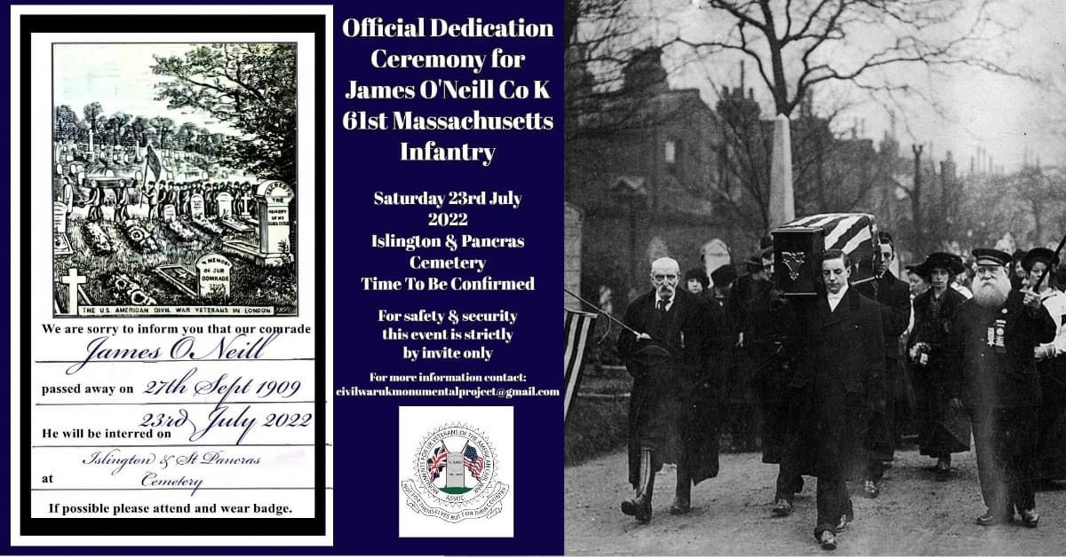
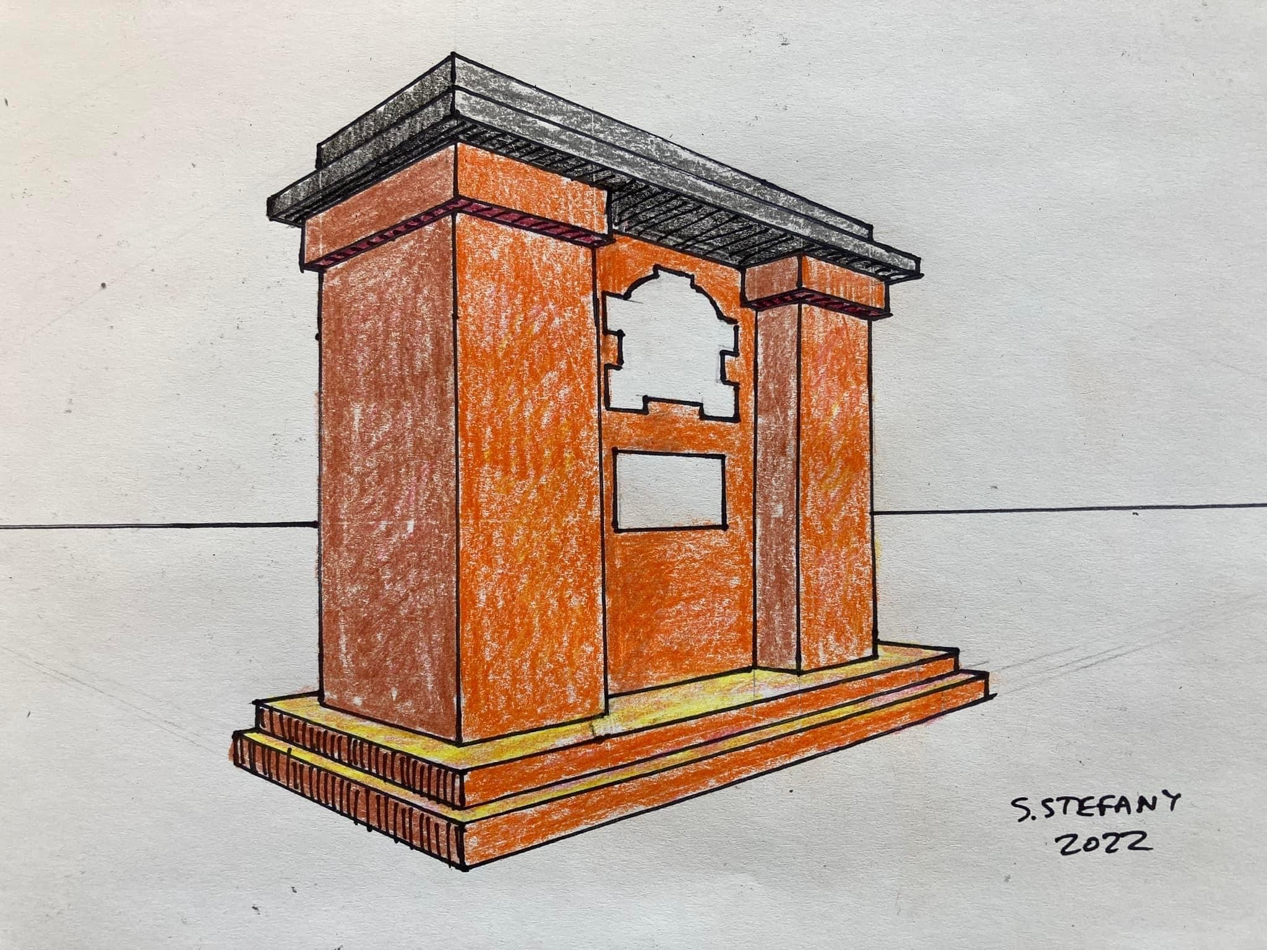

Of course, there are several strands to the Associations work – to fund one single monument to honour the service men and women who served. But also, we will endeavour, where possible, to secure single headstones for their unmarked graves, and create “virtual” monuments online and at events to shed light on their service so that they will not be forgotten. An important part of our work is building on existing surviving lists of veterans so that they are accessible for anyone to view via our social media pages. Information will include the veterans service, dates and places of birth and death too. We hope that by shedding light on their lives during and post war, others will be encouraged to join our work. Which includes cemetery visits as part of field research.

To fund one single monument is not without cost, however, and we are already in the process of formalising its design and wording. So far, we have raised just over £1000 of a £3000 target. But we still need more support. So people wishing to donate can currently do so via paypal using civilwaruknonumentalproject@gmail.com or our “Just Giving Page” https://www.justgiving.com/crowdfunding/americancivilwarukmonumentalproject?utm_term=DZrnvrD7A

Anyone interested in our work is a stakeholder, the only official membership is by joining as a committee member, which brings with it voting rights that allows members to shape the Associations future. Its early days for the Association but as a daughter of a Union Veteran of the American Civil War, I feel too many years have gone by where all American Civil War Veterans should have been honoured in the United Kingdom. We feel actions speak louder than words; American Civil War veterans deserve proactive remembrance, and we plan to fulfil that duty. We will collaborate with any like-minded organisations or individuals to achieve that aim, so that men like my Great-Great Grandfather George Denham are never forgotten.

Adapted from, “The Spartan who climbed Lookout Mountain” by Gina Denham, 2022.

Gina and Darren were invited to the Emerging Civil War Podcast with Chris Mackowski to talk about the monuments for UK Veterans. Visit https://emergingcivilwar.com or search for them on Youtube.

Est, vel elit, congue wisi enim nunc ultricies sit, magna tincidunt. Maecenas aliquam maecenas ligula nostra, accumsan taciti. Sociis mauris in integer, a dolor netus non aliquet, sagittis felis sodales, dolor sociis mauris, vel libero cras. Faucibus at. Arcu habitasse elementum est, ipsum purus pede porttitor class, ut adipiscing, aliquet sed auctor, imperdiet arcu per diam dapibus libero duis. Enim eros in vel, volutpat nec pellentesque leo, tempo ribus scelerisque nec.
Stop Press: this is a mock up of our monument design
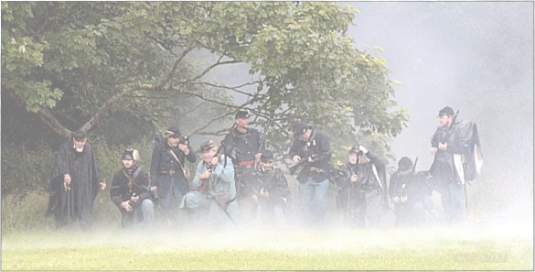

Signals from around the web
Well, i asked for links from both sides for great online content, however we’ve only got stuff of a Northern bias..so id suggest in the words of the late great Douglas Adams: Gentlemen of the South..’bang the sticks together guys’. Thanks to Robert Dickson here for his faves,
Liberty Rifles (Super authentic US stuff - https://www.youtube.com/user/paulbocc96
Atun-Shei Films (lots of varied content on US History, this is the Checkmate Lincolnnites playlist)
https://www.youtube.com/playlist?list=PLwCiRao53J1y_gqJJOH6Rcgpb-vaW9wF0
(Hilariously funny)
Civil War Digital Digest (good but occasional inaccuracies and bias)
https://m.youtube.com/c/CivilWarDigitalDigest

Honorable mentions to..
The following podcasts. I cant resist a long soak in the bath chilling out to civil war history. search for these on the podcast features of your favourite fruit based device:

The Battle of Gettysburg Podcast. If you like your history with style, now thats the style! Slightly too obsessed with Ric Flair. Woo..!
Dan Snows History Hit Channel has also been putting a lot of ACW content

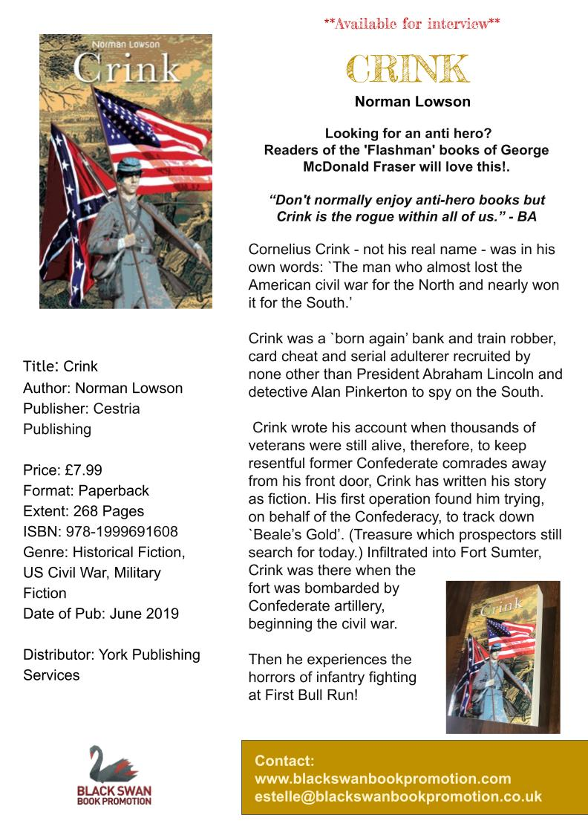

Competition Time
To celebrate the new book by Norman Lowson we have two copies to give away. All you have to do is answer the following question: Which band uses ‘Exstacy in Gold’ as its intro music. Email: john.oakley1@ntlworld.com to win.

Cant wait or want to buy it as a gift? negotiated a top deal for you.

We are delighted to offer you as members a special code for use on YPDBooks.com: Soskan50

This will give members 50% off the RRP on this website for a limited period of time. This code is not case sensitive.

Terminology (A refresher)

Not surprisingly it takes new recruits some time to get to know all the terms and language associated with the forces of the American Civil War (ACW). The older soldiers use terms such as: ‘Company Street’ by second nature and of course new recruits pick up the meanings pretty quickly. It should be noted that this was written for Union troops but most terms here apply to both Union and Confederate. Here are some of the most common:

Company Street. An area which has been allocated for a company to pitch their tentage (in an organized and military fashion) ensuring that the men eat, sleep and are present in one specific area.
Colour line. That area at the head of the company street where the colours and men fall-in, are inspected and march off from. It is also the area where muskets would be stacked prior to ‘breaking ranks.’
Roll call. Usually carried out early morning to check that troops are present or accounted for. May be carried out on in informal basis within the Company Street by the Orderly Sgt irrespective of formal dress (first parade of the morning) or more formally on the Colour Line, prior to handing over the men to the Company Officer. When names are called the men answer; ‘Here’, irrespective of the rank of the senior person in the vicinity.
The Long Roll. The traditional call to arms, signalled by a drummer with a continuous roll. It is the signal, day or night for all soldiers to arm themselves and parade on the Colour Line in ‘double-quick’ time.
Fresh fish. Recruit.
School of the Soldier. Name given to the basic military training given to ‘fresh fish’. Usually recruits are taught in small squads of 6 or less, occasionally one to one training is given. This includes:
o Positions and Facings.
o The Manual of Arms.
o Loading and Firing.
o Marching in a squad.
Marching in ‘quick time’. At a speed of 110 paces to the minute and a stride of 28 inches.
Marching in ‘double-quick time’. At a speed of 165 paces to the minute and a stride of 33 inches. Muskets are brought to the ‘Right shoulder shift position’ on receipt of the order.
Line of battle. Two ranks of troops facing front in a position to bring fire to bear upon an enemy.
Company drill. The drill required to move a body of troops from one location to another in order to bring fire to bear on an enemy in the quickest possible time. This includes:
o Forming column of fours.
o Changing direction by; files, flanks, obliques, and wheeling’s. Company into line.
Battalion drill. Where several companies parade together in order to practice moving a large body of troops in drill, which ensures the men are placed into line of battle in front of an enemy in the quickest possible time. In a full battalion of ten Companies, the third Company is the ‘Colour Company’.
File closers. Officers and Sgts posted outside the body of troops are designated as file closers. Posted in the rear of the company when in line of battle, it is their duty to see that the men pay attention to their duty, preserve order, march properly, keep closed up and do not ‘straggle’ on the march. They will also restrain any would-be deserters trying to break ranks to the rear during combat
Seeing the elephant. Being in combat for the first
Time.
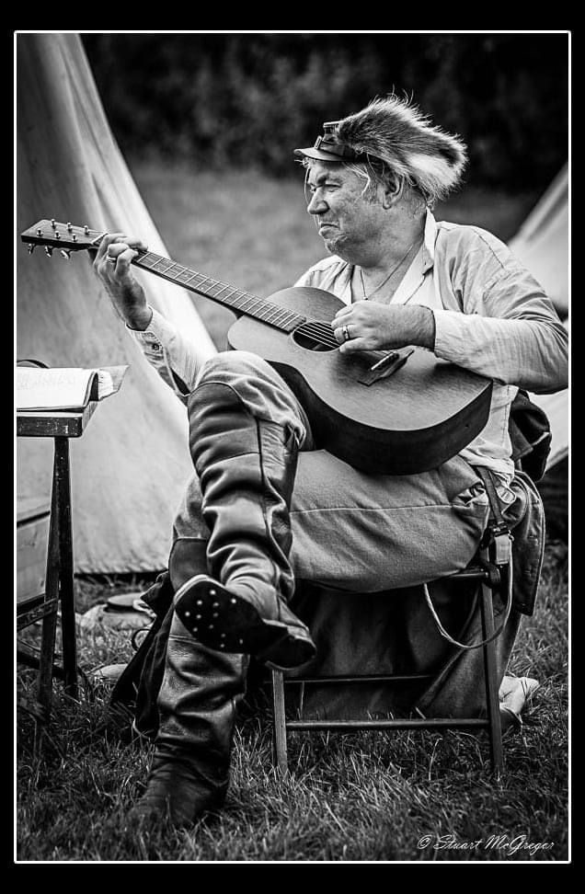
Seeing the elephant. Being in combat for the first time.
Shoulder straps. Officers.
SoSkAn’s Minimum Authenticity Document. This must be read by every member, irrespective of time served. It lays down the rules for our standards of dress and Impression and the time scale in which all members have to comply. Access to this document and to the Rules and Regulations of the Society can be obtained at: www.soskan.co.uk It is the responsibility of each individual to adhere to this document within the time frame shown but never be afraid to ask for help.
1st Sergeant. Equitable to a Sergeant Major in the British Army. Also known as the Orderly Sgt, or just plain ‘Orderly’ to the soldiers. Was directly responsible to the Company Officer for the administration, the company roll (company members to always be ‘present or accounted for’), discipline, detailing fatigues, guards and pickets, ensuring all orders duly enforced and obeyed, to draw and issue to the company all supplies of rations, clothing and ammunition, to see that the men kept their persons, clothing, arms and tents in serviceable condition. Plus a myriad of other responsibilities. His was the responsibility of ‘showing by example’ that all was asked, could be achieved. To help him carry out these duties there were four Sgts and eight Cpls to a full-size company of one hundred souls. It should be noted that Confederate Company’s kept to the pre-Civil War cadre of four Cpls.
Light marching order: Dress required for drill, immediate battle or short march, comprising; leathers, haversack and water bottle, plus issue of ammunition.
Heavy marching order: As above with the addition of knapsack or blanket roll, shelter half, plus issue of rations.
Sand: Period and Soldier’s slang for grit/determination.
Bully: Soldier’s slang for outstanding/great!
Grayback: The name given to the lice (pediculus) that infested the men’s clothing. In order to rid themselves for a while, the infested clothing had to be boiled, however the men were rarely in a situation where that was an option. They would sit on the ground, shirts on laps, find a louse and ‘pop’ it between their thumbnails as the only way they had to get rid of them. This was known as ‘skirmishing’ in camp. Pediculus was no respecter of rank and all soldiers, even the Generals, succumbed to them at some stage or another. One of the reasons that hair was kept fairly short was in order to deter the lice and make them easier to find and kill.
Skinner: Soldier’s term for Sutler, many of whom took advantage of the soldiers and were seen to ‘skin’ them of their hard-earned wages.

Thanks to Roy Dann for the article

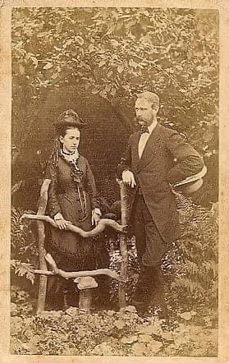

Military etiquette.

-When an officer enters the Company Street, the senior soldier present gives; ‘attention company’, whereupon all soldiers stand, the senior man only salutes. To stop us all bobbing up and down during the day, this should only occur once at the start of the military day.
-Approaching an officer, Union or Confederate, salute.
-Passing the National flag when out of the Company Street, salute.
-Out of the Company Street, always remain ‘dressed’ i.e. jacket and hat on, at least top button of jacket fastened.
-When ‘Colours’ are paraded in the Battalion lines, all ranks stand to attention and the e senior soldier only salutes.

1860’s etiquette.
-Touch or raise your hat when meeting females, offer a greeting.
-Stand up when females enter your vicinity in the Company Street.
-Never remove outer garments in front of females, it was considered the height of bad manners to be seen by them in shirtsleeves. Modesty in everything

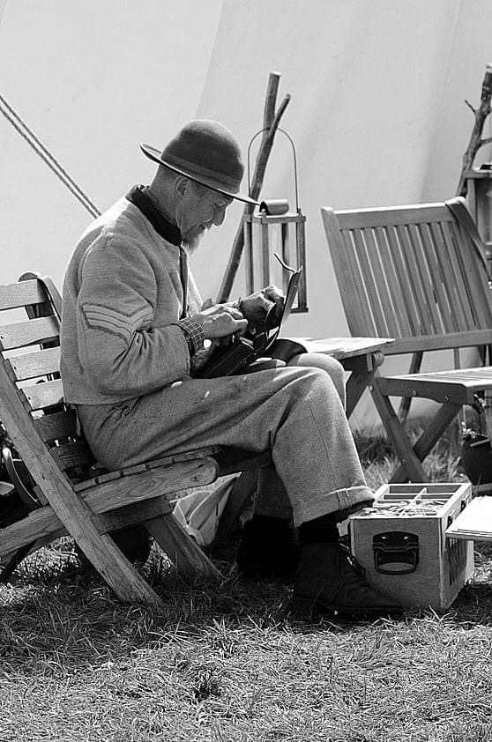

Events list reminder
June 2ND Queens Platinum Jubilee 70 Gun Salut Hastings. E Beach St, Old Town, Hastings Tn34 3AR.

JUNE 11TH/12TH ASHFORD & FOLKESTONE MILITARY SHOW SELLINDGE KENT. TN25 6EP

JULY 2ND/3RD THE CAPEL MILITERY SHOW, CAPEL SURREY. RH5 5HJ

JULY 16TH/17TH BATTLES FOR VICTORY SHOW BIRCINGTON, KENT CT7 0BH

AUGUST 13TH\14TH ECHOES OF HISTORY RETTENDON ESSEX CM3 8DL

AUGUST 27/28/29 MILITARY ODYSSEY DETLING KENT ME14 3JE
